Image | 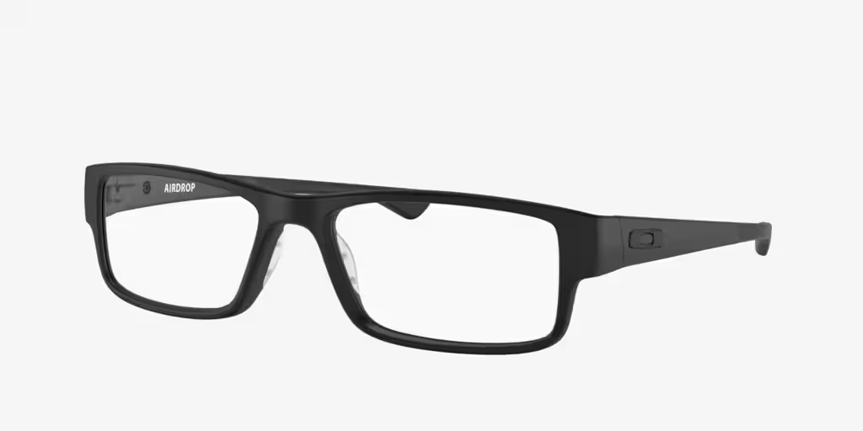
Brand | MICHEAL KORS
Model Name | OX046 AIRDROP
Price | RS 1800
PRODUCT DETAILS

